

**2 AUTO – IG – IR – TI**

**English Reinforcement**

**Q2**

**Chapter 1 – Personality**



**Denis Thomas**

**De Witte Justine**

**Fossion Juliette**

**Hayen Stéphanie**

**Léglise Florence**

**Nisolle Olivia**

**Table of contents**

**1.** **General information** 3

Aim of the course 3

Structure 3

Exam 3

**2.** **Introduction** 4

3. **Let’s get to know each other** 5

A. Learn a bit more about yourself 5

B. Your strengths and weaknesses 7

**4.** **Personality types** 8

**5.** **What is your personality** 10

A. Myers & Briggs test: what is it? 10

B. Homework 12

C. Which video game character shares your personality type? 14

**6.** **Hard skills and soft skills** 22

# **General information**

## Aim of the course

The aim of this course is to focus on oral interactions (discussions, debates, expressing your opinion…). The syllabus will provide various topics and situations that will be the base for our oral interactions.

Because you are studying to become a professional worker in your field, this course will focus on topics such as the world of work, finding a job, writing professional documents and handling job interviews.

## Structure

The syllabus is structured as follows:

* Chapter 1: Personality
* Chapter 2: CV and cover letter + LinkedIn
* Chapter 3: Job interview
* Chapter 4: The world of work
* Chapter 5: Job Hunting

## Exam

The exam will consist of **two parts**: a written assignment and an oral exam :

1. The **written assignment** will consist of creating a LinkedIn profile (deadline still undetermined).
2. The **oral exam** will consist of
   1. Handling a job interview as efficiently and professionally as possible and
   2. Being able to answer questions about the various topics we will have covered throughout the semester. Of course, the exactitude of your English will be of great importance.

# **Introduction**

***Listening/watching activity*: Watch the following clip from the film “Jumanji” and guess what we are going to talk about today (link:** https://www.youtube.com/watch?v=dSKIEjS3f9Y).

**But first, a few vocabulary words:**

|  |  |
| --- | --- |
| A skill | Une compétence |
| “There’s gotta be” | Il doit y avoir |
| Fearless | Sans peur |
| Smouldering intensity | Intensité qui se consume lentement / constante |
| Gorgeous | Magnifique |

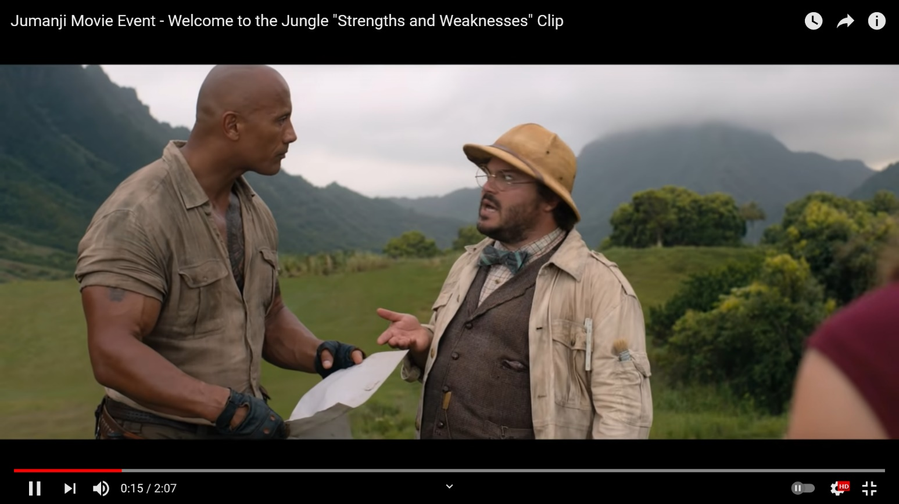

**Today, we are going to talk about** switching personality / different types of personality

* + - Strengths vs weaknesses
    - None = Aucun
    - Martial Arts = Arts martiaux
    - Venom --> Poison

# Let’s get to know each other

## Learn a bit more about yourself 🡪 SKIPPED

***Oral activity*: form groups of 3 or 4 students and discuss a few questions together. There are extra questions on the next page.**

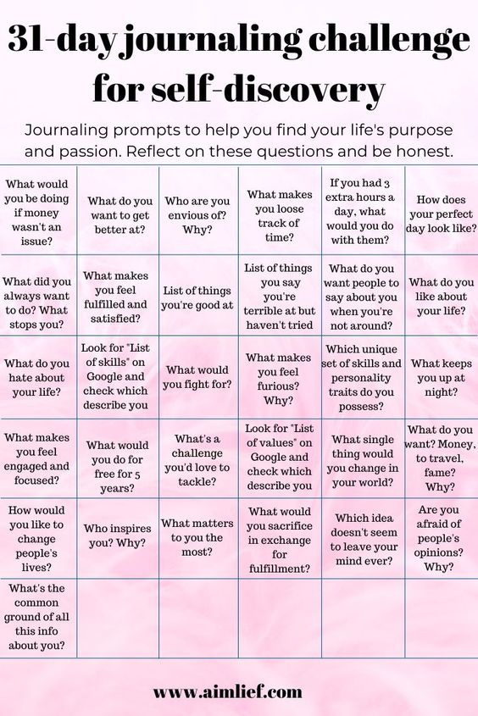

**Extra questions**

1. What images spring to mind when you hear the word ‘personality’?
2. How would you describe your personality?
3. Are you happy with your personality?
4. How has your personality changed over the years?
5. What or who has helped shape your personality?
6. What of your personality traits do you like most?
7. Do you think you have a strong personality?
8. What word would sum up your personality?
9. Do you think you have an outgoing personality?
10. Is your true personality always on show or do you hide parts of it?
11. What are the personality differences between you and other family members?

## Your strengths and weaknesses

***Reading/writing activity*:**

**Have a look at the picture below. Do you know all the words?**

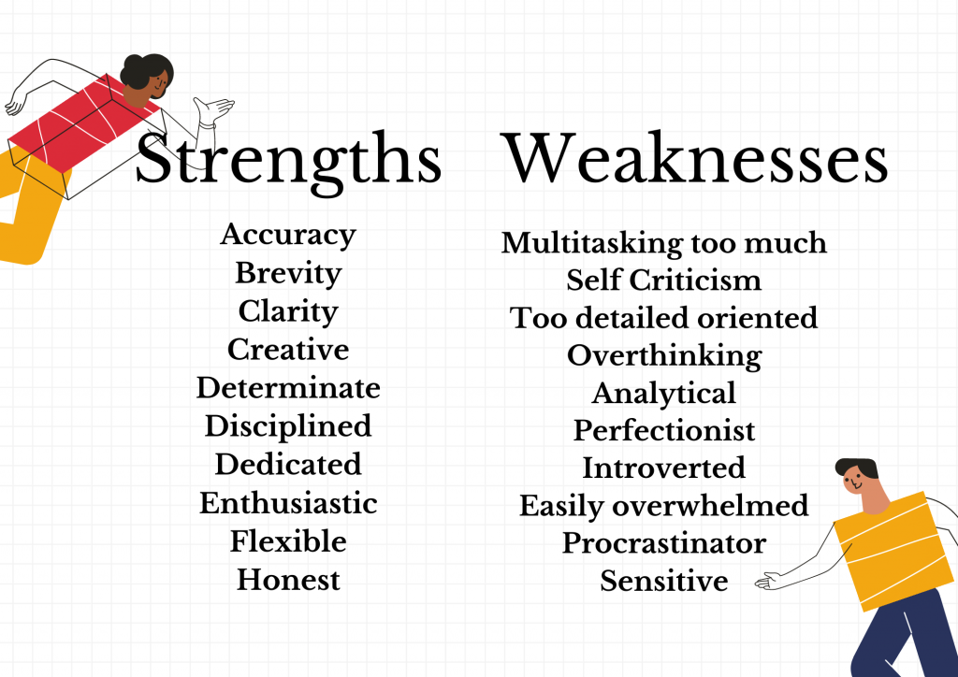

= Raisonné

**Sensible**

= Susceptible

= Glandeur

= Facilement débordé

= Introverti

= Perfectionniste

= Sur-analyse

= Suréflexion

= Trop minutieux

= Se critique trop

= Trop multitachache

Honnète =

Flexible =

Enthousisate =

Engagé =

Discipliné =

Déterminé =

Impliqué =

Clair =

Concis =

Précis =

**Among all these strengths and weaknesses, choose two that match with your personality, and two that you think you don’t have. You can also pick strengths that are not listed above.**

|  |  |
| --- | --- |
| **2 strengths I have** | **2 weaknesses I have** |
| **1. Honest**  **2. Dedicated** | **1. undisciplined**  **2. Too detailed oriented** |

***Oral activity*: Explain your choices to the members of your group.**

# **Personality types**

***Listening activity*: The Best Jobs for Each Personality Type (link:** <https://youtu.be/StshYpaR2J0)>

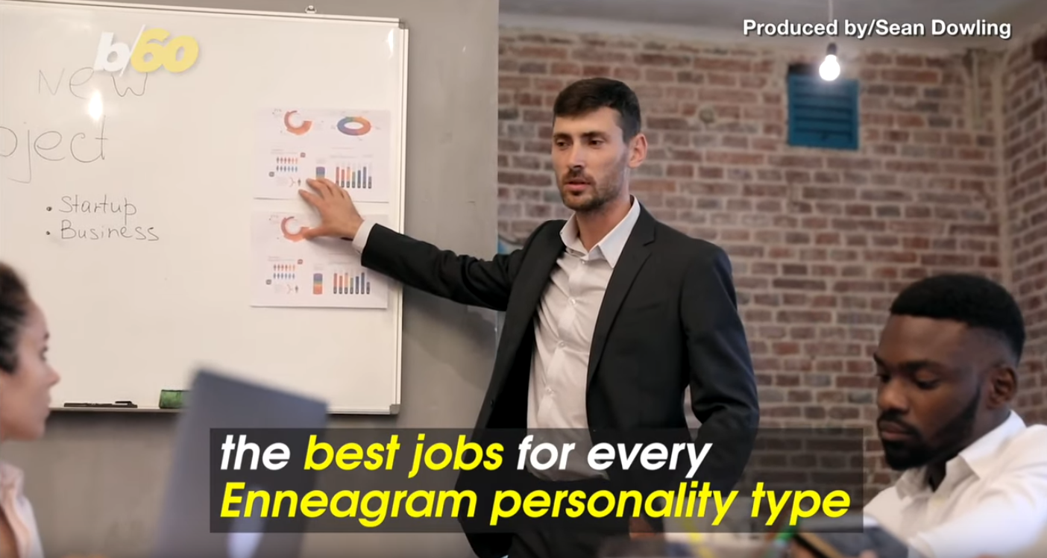

**Give a possible reason why some people hate their job:**

**The Enneagram Institute identified 9 personality types. Can you list them?**

**1.**

**2.**

**3.**

**4.**

**5.**

**6.**

**7.**

**8.**

**9.**

|  |  |
| --- | --- |
| **Personality** | **Character traits** |
|  | pragmatic and driven |
|  | rational, self-controlled, perfectionist |
|  | loves to be the boss |
|  | lives for adventure but is all over the map with no clear structure |
|  | generous people-pleaser, warm, kind and engaging |
|  | dramatic, expressive and artistic |
|  | wants to know everything about the world around them |
|  | doesn’t want to rock the boat, they want to help |
|  | a worrier, likes things the way they are; even if they’re not great |

**🡪Match the personality types from the above exercise with the given character traits.**

**VOCABULARY**

|  |  |
| --- | --- |
| **English** | **French translation** |
|  |  |

***Oral activity*:** **discuss the following questions with one of your classmates:**

* Have you ever had a student job? How was your boss?
* Do you think bosses adapt to the personality of their employees? Or is it the other way around?
* Have you ever managed a team (sports, club, etc.)? How did you build or participate in building a team spirit?

# **What is your personality**

## Myers & Briggs test: what is it?

There are plenty of personality tests online. Have you ever taken a test to see to which Harry Potter House you belong? Do you know what your wand is made of? What’s your patronus?

More seriously: Have you ever taken a (serious) personality test online? Do you know the “Myers Briggs personality types”?

***Watching/listening activity*:**

**Before watching a video to learn about that test, here are some useful vocabulary words:**

|  |  |
| --- | --- |
| ~~Outrageously inaccurate~~ |  |
| ~~Insightful~~ |  |
| ~~To relate to~~ |  |
| ~~A misconception~~ |  |
| ~~To be drained of energy~~ |  |
| ~~A pattern~~ |  |
| ~~Hands-on experience~~ |  |
| ~~Orderly~~ |  |
| ~~To lean towards~~ |  |

**Now, watch the video.**

Source: <https://www.youtube.com/watch?v=M4YLO-2Tb2w>

**Answer these questions with the help of the video:**

1. **How does the test work?**
2. **Give details about each distinction:**
   1. **Introvert VS Extrovert**
   2. **Intuition VS Sensing**
   3. **Thinking VS Feeling**
   4. **Judging VS perceiving**

**Now that you know about these 8 categories, in which ones would you fit the best? Why?**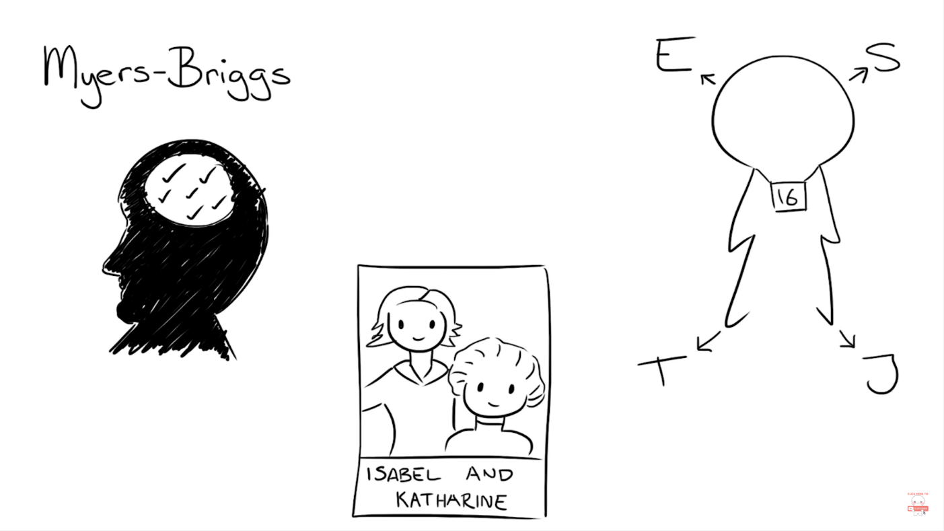

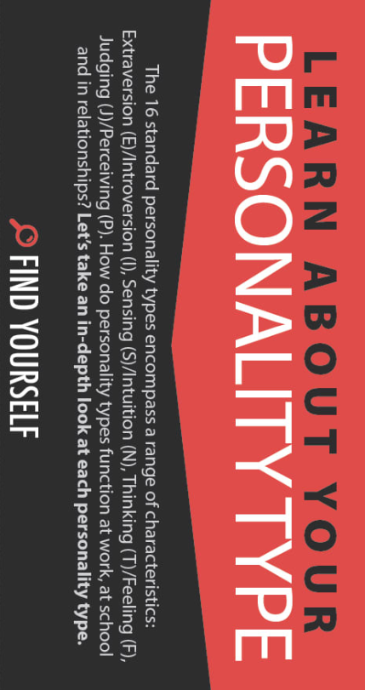

## ~~Homework~~

**~~Home preparation:~~** ~~Complete the following personality test before coming to class. Analyse your results and save them, as we’ll~~ have a talk about the different types of personality, as well as the most ‘adequate’ jobs related to them.

Link: [Free personality test, type descriptions, relationship and career advice | 16Personalities](https://www.16personalities.com/)

Write down the vocabulary words you learn while doing the test:

|  |  |
| --- | --- |
| **English** | **French** |
|  |  |
|  |  |
|  |  |
|  |  |
|  |  |
|  |  |
|  |  |

My personality type:

Copy paste your results here:

My strengths and weaknesses (briefly):

Famous person I am linked to (see next image):

**Discussion:** What result did you get? What do you think of it (do you agree or not)? Did you think you belong to another type? Why?

**Discussion**: Now you have your result, have a look at the following image. Take your time to analyse it and then we’ll discuss your interpretation and ideas about it. Do you agree? Do you find it normal?

## Which video game character shares your personality type?

***Reading activity*: read the following text and choose the character which best represents your personality.**

1. **ISTJ: Teemo – League of Legends**



Teemo is our prime example of an ISTJ because of his background as a stealthy assassin. His reputation as a dependable and quiet super soldier has pushed him to become a menace on Summoner’s Rift because of his organized, methodical gameplan. He drops traps and stealths around the map, ready to take down any poor, mispositioned soul.

**ISTJ’s in General:** Quiet, serious, earn success by thoroughness and dependability. Practical, matter-of-fact, realistic, and responsible. Decide logically what should be done and work toward it steadily, regardless of distractions. Take pleasure in making everything orderly and organized – their work, their home, their life. Value traditions and loyalty.

1. **ISTP: Link – The Legend of Zelda**

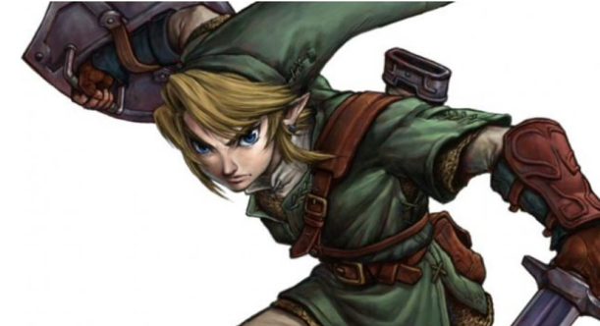

Link, the quiet swordsman, is our ISTP pick. Responsible for saving the kingdom of Hyrule from Ganondorf, Link has proven himself as a crafty and resourceful adventurer. Besides fighting giants and demons, he must jump headfirst into dungeons and solve ancient puzzles to protect Princess Zelda and all of Hyrule. With his creativity and intuition, Link has been able to protect the kingdom time and time again, whether it be from the Calamity or a giant, grinning moon crashing into the world.

**ISTPs in General:** Tolerant and flexible, quiet observers until a problem appears, then act quickly to find workable solutions. Analyze what makes things work and readily get through large amounts of data to isolate the core of practical problems. Interested in cause and effect, organize facts using logical principles, value efficiency.

1. **ISFJ: Big Daddy – Bioshock**

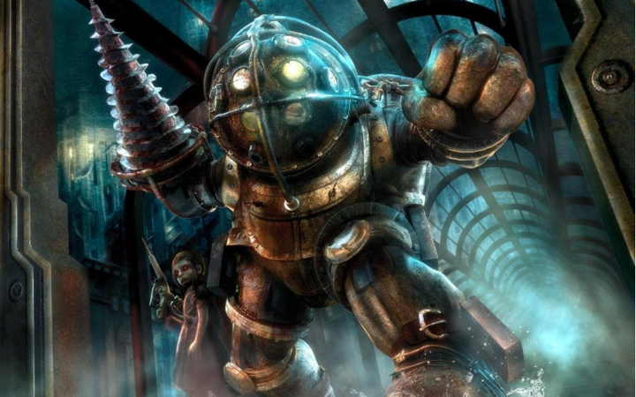

ISFJ’s, while quiet, are extremely dependable and committed to those around them. Known for their loyalty and role to protect Little Sisters, the Bioshock series’ mascot, the Big Daddy, is the epitome of this. Their entire role is to protect these young girls from the drug-crazed Splicers that infest Rapture. As a Big Daddy, nothing is more important than the safety of the Little Sisters, ready to throw themselves into the fray just to ensure their safe return home. Dependable and loyal, the Big Daddy is our pick to represent ISFJ’s.

**ISFJs in General**: Quiet, friendly, responsible, and conscientious. Committed and steady in meeting their obligations. Thorough, painstaking, and accurate. Loyal, considerate, notice and remember specifics about people who are important to them, concerned with how others feel. Strive to create an orderly and harmonious environment at work and at home.

1. **ISFP: Dhalsim – Street Fighter**

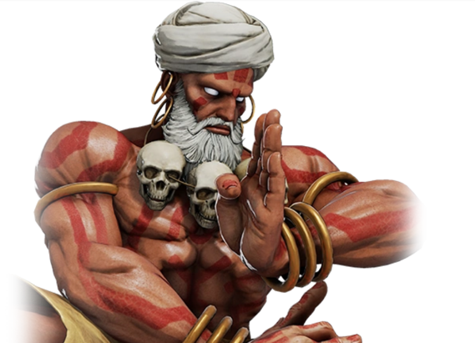

What is more representative of the friendly and loyal disposition of an ISFP than the altruistic Dhalsim from Street Fighter? As a pacifist and protector of the poor, Dhalsim fights only to protect those who cannot protect themselves. He is a loving father and husband who is completely committed to non-violence. Despite having to use his powers to fight, he never uses more force than necessary and ensures that his strength is only ever used for good.

**ISFPs in General:** Quiet, friendly, sensitive, and kind. Enjoy the present moment, what’s going on around them. Like to have their own space and to work within their own time frame. Loyal and committed to their values and to people who are important to them. Dislike disagreements and conflicts, do not force their opinions or values on others.

1. **INFJ: Geralt – The Witcher 3**



A stoic character who is portrayed as taciturn and cunning. That’s who INFJ’s are, and that’s exactly what we see in Geralt from the Witch series. Like other INFJs Geralt rarely takes partakes in the joys of friendships, but can be fiercely loyal when it comes to defending the lives of those he is close to. He recognizes the morally grey world that he lives in easily, and as a result his honor sways both ways. So too will INFJs find themselves developing and honing a vision of the common good, quickly learning that doing what is right doesn’t always mean doing what is good.

**INFJs in General**: Seek meaning and connection in ideas, relationships, and material possessions. Want to understand what motivates people and are insightful about others. Conscientious and committed to their firm values. Develop a clear vision about how best to serve the common good. Organized and decisive in implementing their vision.

1. **INFP: Claude von Riegan – Fire Emblem**

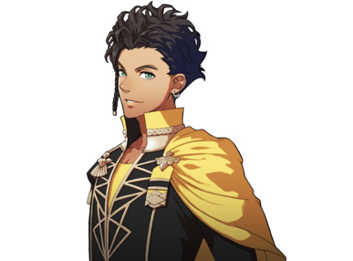

He’s sly. He’s smart, He’s a leader. Claude is our pick to represent INFP’s because of his outside of the box thinking. As the future leader of the Lancaster Alliance, he is always in the pursuit of knowledge in order to better equip himself for leadership. Seeing the beauty and power of man, he believes that people hold the power to peace, not the traditional values and nationalism that has divided the land of Fódlan. With his constantly unquenched search for the truth, he is clever and reliable to always get the job done, including being the leader for those around him.

**INFPs in General**: Idealistic, loyal to their values and to people who are important to them. Want an external life that is congruent with their values. Curious, quick to see possibilities, can be catalysts for implementing ideas. Seek to understand people and to help them fulfill their potential. Adaptable, flexible, and accepting unless a value is threatened.

1. **INTJ: G-Man – Half-Life**

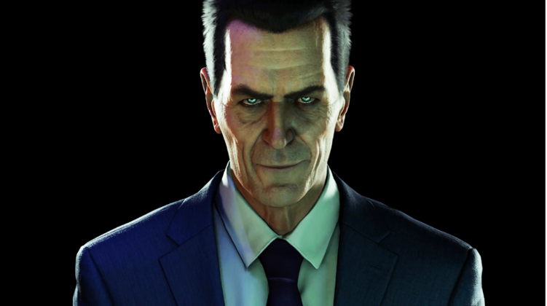

Mysterious and omniscient, the G-Man is quite possibly one of the most iconic characters in all of gaming. He is responsible for bringing Gordan Freeman into the various conflicts occurring within the Half-Life series. The G-Man’s role has been to lead Gordan through the battle against the Combine forces. With his ability to control time and space, the G-Man organizes Gordon to be in the right time and place so that he can disrupt the power struggles going on between Black Mesa, the Vortigaunts, and the Combine. He is the man who dictates the conflicts and is able to change the flow of time.

**INTJs in General:**Have original minds and great drive for implementing their ideas and achieving their goals. Quickly see patterns in external events and develop long-range explanatory perspectives. When committed, organize a job and carry it through. Skeptical and independent, have high standards of competence and performance – for themselves and others.

1. **INTP: Patricia Tannis – Borderlands**



More interested in ideas than social interaction, we think the thinker is the embodiment of Patrician Tannis from the Borderlands series. Cold and calculating Tannis is more interested in solving the problem than dealing with the humans that created it in the first place. Like the quintessential INTP she can be skeptical, and critical, but whether it’s eridian or sirens, she, like other INTP’s is always attuned with an unusual ability to focus in depth to solve problems in areas that she cares about.

**INTPs the general:** Seek to develop logical explanations for everything that interests them. Theoretical and abstract, interested more in ideas than in social interaction. Quiet, contained, flexible, and adaptable. Have unusual ability to focus in depth to solve problems in their area of interest. Skeptical, sometimes critical, always analytical.

1. **ESTP: Sonic the Hedgehog – Sonic the Hedgehog**



Can you keep up? Sonic sure can with his fact acting and energetic approach to life. As our ESTP pick, his signature speed is not limited just to running. He is spontaneous and ready to attack all his problems as fast as possible, often throwing himself into the fray before anyone else can. When Dr. Eggman attacks, all he cares about is taking him down. How? Well, he can figure that out on the go.

**ESTPs in general:** Flexible and tolerant, they take a pragmatic approach focused on immediate results. Theories and conceptual explanations bore them – they want to act energetically to solve the problem. Focus on the here-and-now, spontaneous, enjoy each moment that they can be active with others. Enjoy material comforts and style. Learn best through doing.

1. **ESTJ: Donkey Kong – Donkey Kong**



He’s the leader of the bunch. You know him well. He’s finally back – as our ESTJ pick. Fiercely loyal DK will act like other ESTJs and do whatever it takes to take care of those they care about. He is a quick acting, powerful, and boisterous leader. Leading with his strength and coconut gun, Donkey Kong is all about getting results as quickly as possible. Whether it’s swinging or spinning the end game is always in sight.

**ESTJs in General:** Practical, realistic, matter-of-fact. Decisive, quickly move to implement decisions. Organize projects and people to get things done, focus on getting results in the most efficient way possible. Take care of routine details. Have a clear set of logical standards, systematically follow them and want others to also. Forceful in implementing their plans.

1. **ESFP Rex – Xenoblade Chronicles 2**



After being thrusted into responsibility early in life, he spends much of his life providing and caring for the orphans in his village. As their needs begin to grow, he takes a risky job that ends with him being binded with the blade Pyra. Outgoing and confident, Rex’s first instinct is to throw himself into battle to protect those he cares about. His confidence may barrel him into problems, but his flexibility allows him to adapt quickly and learn how to deal with these issues quickly. Tenacity and spontaneity is what makes him Rex and our ESFP pick.

**ESFPs in general:** Outgoing, friendly, and accepting. Exuberant lovers of life, people, and material comforts. Enjoy working with others to make things happen. Bring common sense and a realistic approach to their work, and make work fun. Flexible and spontaneous, adapt readily to new people and environments. Learn best by trying a new skill with other people.

1. **ESFJ: Isabelle – Animal Crossing**



Good morning! It’s Isabelle here to be our ESFJ pick. Her warmhearted, kind presence in the Animal Crossing universe has cemented her as a fan-favorite in the series. She works to help ensure that everyone in the city or island is happy, ready to host events for the enjoyment of those around her. With Isabelle, nothing is more important than her residents, booming with positivity and determination every step of the way.

**ESFJs in general**: Warmhearted, conscientious, and cooperative. Want harmony in their environment, work with determination to establish it. Like to work with others to complete tasks accurately and on time. Loyal, follow through even in small matters. Notice what others need in their day-by-day lives and try to provide it. Want to be appreciated for who they are and for what they contribute.

1. **ENFP: Papyrus – Undertale**



“I HAVE TO MAKE EVERYONE GIVE UP GIVING UP!” These kinds of words are exactly why Papyrus from Undertale is the epitome of an ENFP. Extremely boisterous and enthusiastic, Papyrus is ready to give out affirmation and support to anyone who needs it. While a bit ditzy, he is always genuine and unapologetically himself. Nothing would describe him more than the people’s champion.

**ENFPs in general:** Warmly enthusiastic and imaginative. See life as full of possibilities. Make connections between events and information very quickly, and confidently proceed based on the patterns they see. Want a lot of affirmation from others, and readily give appreciation and support. Spontaneous and flexible, often rely on their ability to improvise and their verbal fluency.

1. **ENFJ: Mercy – Overwatch**



The doctor is in — Mercy’s name couldn’t give away her personality type any more. She, like other ENFJ’s, is highly attuned to the emotions and needs of others, and will fly to them (play on words entirely intended) when they need help. She has a selfless and responsive role in her team, constantly weaving through a fight to fully empower her teammates to live up to their potential. While maintaining a backline position, Mercy is able to lead her team, healing and inspiring them all the way to a win.

**ENFJs in general:** Warm, empathetic, responsive, and responsible. Highly attuned to the emotions, needs, and motivations of others. Find potential in everyone, want to help others fulfill their potential. May act as catalysts for individual and group growth. Loyal, responsive to praise and criticism. Sociable, facilitate others in a group, and provide inspiring leadership.

1. **ENTP: Phoenix Wright – Ace Attorney**



What is better to represent “The Debater” than the #1 lawyer in videogame history? Phoenix Wright from Ace Attorney is an extremely quick-witted lawyer who is known for his ability to turn almost hopeless cases on its head. Beyond his background as a lawyer, he is an incredible poker player who, during his time playing, went undefeated. He is extremely astute and are able to pull information from anything and anyone, making him our ENTP pick.

**ENTPs in general:** Quick, ingenious, stimulating, alert, and outspoken. Resourceful in solving new and challenging problems. Adept at generating conceptual possibilities and then analyzing them strategically. Good at reading other people. Bored by routine, will seldom do the same thing the same way, apt to turn to one new interest after another.

1. **ENTJ: GlaDoS – Portal Series**



ENTJs are frank, decisive, logical and forceful in presenting their ideas. Who else could we choose but GlaDos from the Portal Series. Though we don’t think you’re going to be killing scientists anytime soon, GlaDos like other ENTJs embodies the ideas of being someone who implements comprehensive systems to solve organization problems (because well, she was made that way). It’s all about the long con with GlaDos, and her long term plans to kill you end up being almost methodical. Other ENTJs will find enjoyment in this long-term planning/goal setting. Hopefully you don’t use those plans to kill anyone.

**ENTJs in general**: Frank, decisive, assume leadership readily. Quickly see illogical and inefficient procedures and policies, develop and implement comprehensive systems to solve organizational problems. Enjoy long-term planning and goal setting. Usually well informed, well read, enjoy expanding their knowledge and passing it on to others. Forceful in presenting their ideas.

# **Hard skills and soft skills**

***Listening activity*: What are soft skills?**

**Listen to the video and answer the questions (link:** https://www.youtube.com /watch?app=desktop&v=Tiy2LONr050 )

1. How can we summarise soft skills?
2. Define what hard skills are.
3. Complete the sentence: It’s often said that ________________________ will get you ________________________ but you need ________________________ to ________________________
4. Building effective soft skills has 5 main advantages: Develop
5. Soft skills are a mix of two features, which ones (give examples)
6. Speaking about a concrete application, what is the ‘advantage’ of soft skills compared to hard skills?

***Speaking activity***:

* Had you already heard about soft skills and hard skills before? If yes, in which context?
* What is your opinion on hard and soft skills? Which one would you emphasise if you were looking for a job? Why?

*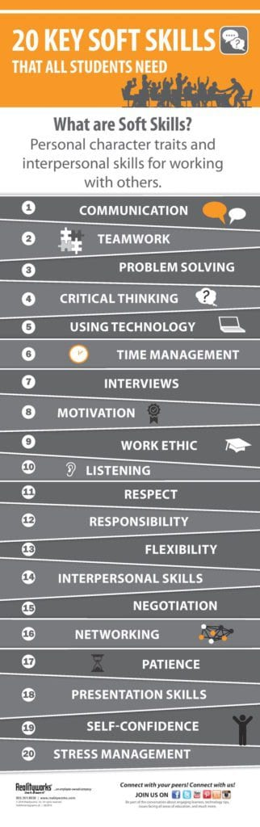****Writing activity***: take a few minutes & try to describe yourself according to your soft skills. Have a look at the image on the right to help you. Write your presentation in the following box.

**GAME: Quizlet live:** Go on <https://quizlet.com/live> with your phone and enter the code shared by your teacher.  
Be the fastest to answer.

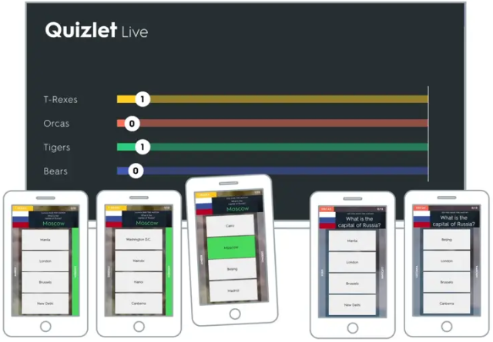

**You can also study the most common soft skills on Quizlet, following this link:** <https://quizlet.com/_9cx7z8?x=1jqt&i=1f4cuy>

***Oral activity***: **In groups, speak about the following questions. We’ll then summarise the different opinions.**

* What hard and soft skills are highly appreciated in your study field?
* Can you think of any more precise hard skills linked to your studies?
* Which skills would you like to develop and why?
* Can you give different examples in which it is useful to have specific soft skills?
* Think about all we have done so far… Can you think of particular soft skills that could match your personality type and your strengths (and weaknesses)?

